**DAILY ONLINE ACTIVITIES SUMMARY**

|  |  |  |  |  |  |  |
| --- | --- | --- | --- | --- | --- | --- |
| **Date:** | | **1/06/2020** | | | | |
| **Name of the Faculty** | | **Ankitha Shetty** | | | | |
| **No. of Students Allotted for monitoring** | | | | **16** | | |
| **Progress** | | | | **Good** | | |
| **Whether collected report from all the allotted students** | | | | **12 students are updating daily**  **2 students are involved in online activity.**  **2 students are not uploading anything.** | | |
| **Online Test Summary** | | | | | | |
| **Subject** | **Operation Research** | | | | | |
| **Semester** |  | | | **Duration** |  | |
| **No. of students Taken** | | |  | **Passing %** |  | |
| **Certification Course Summary** | | | | | | |
| **Course** | | 1) Webinar on personality development through online courses, three dimensional learning  2)webinar on understanding social media through analytics | | | | |
| **Certificate Provider** | | 1)Vivekanada Institute of technology  2)Shree Rama Krishna Institute of technology | | **Duration** | | **1 hour** |
| **Coding Challenges** | | | | | | |
| **Problem Statement:** | | | | | | |
| **Status:** | | | | | | |
| **Uploaded the report in Github** | | | | **Yes** | | |
| **If yes Repository name** | | | | <https://github.com/ankishetty91/ankitha-daily-report> | | |
| **Uploaded the report in slack** | | | | **Yes** | | |

**Certification Course Summary**



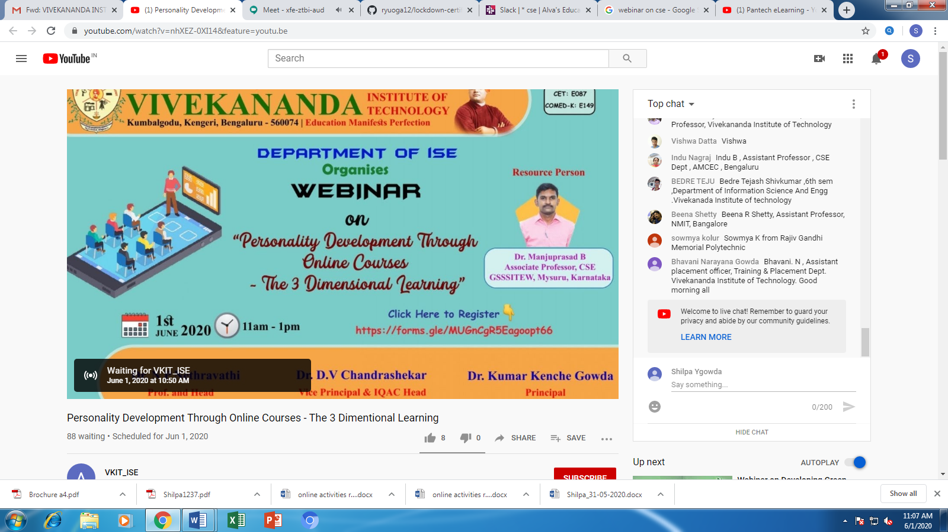

**Students Report:**



